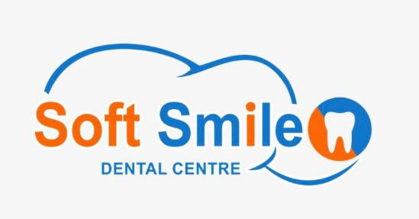

Treatments & procedures

* **Smile Design** – Smile make over & immediate make overs
* **Orthodontics** – braces/Clips to push in or align the teeth  
  Fixed and removable appliances  
  Invisible braces and regular braces.
* **Endodontics** – RCT-Root Canal Treatments.
* **Conservative Dentistry**-Light Cure Resin Fillings  
  Dowel Pin/Screws, Post & core build ups
* **Prosthodontics** – Artificial teeth-Dentures  
  Fixed and removable dentures  
  Ceramic Fixed Dentures(Both Metal & Metal free Fixed dentures)  
  Unbreakable Flexible Removable Dentures
* **Oral And Facio maxillary Surgeries**.  
  Minor surgeries-Wisdom tooth removal, operculectomy, Frenum removal  
  Major surgeries-Orthognathic surgery, Surgeries for jaw fractures.
* **Periodontics** – Gum treatments  
  Teeth cleaning/scaling, Deep cleaning, Flap surgery-gum surgery-Laser surgeries.
* **Paedodontics** – Dental treatments for children  
  Concious sedation,Short GA DentalTreatments for children.

Term courses(very soon)

**Short term courses** For BDS professionals

1. Minor Oral surgeries-Wisdom tooth removal, Opperculectomy & frenectomy.
2. Rotary endodontics.
3. Laser gum surgeries.
4. Smile design-Immediate make overs.
5. Orthodontics for general practitioners.
6. Emergency management in Dental clinics.

**Long term course**

1. Dental Hygenists – 2 years course.Eligibility-12 th std.
2. Dental Mechanics – 2 years couse.Eligibility-12th std.
3. Dental clinic management (DCM) course – One year-Any degree.
4. Endodotics-Rotary endodontics. BDS.
5. Orthodontics-Fixed appliances. BDS.
6. Minor oral surgeries, BDS.

**Dental Tourism**

National & International Dental Tourism.  
Process is on for tie up with private tour operators.  
Local and outstation tours are arranged while the treatments are in process.

**Issues**

QR code for payments are sent through whatsapp

Pulse digital

Framework

ISSUES:

CAVITIES, TOOTH ACHE, BLEEDING GUMS, JAW PAIN, RESTRICTED OPENING, WISDOM TOOTH ISSUES